Modeling Doxy PEP coverage

Mathematical model

Coverage formulation
Let:
- $C_{t}$ = fraction of population currently on treatment (coverage)
- $u$ = fraction of population starting treatment per time step (uptake)
- $λ$ = discontinuiation rate

Duration on treatment is exponentially distributed:
$$P(\text{dur}>t)=e^{-λt}$$
- Persistence after 1 year:
$$P=P(\text{dur}>1)=e^{-λ}$$

Population approximation:
$$Ct+1​=u+(1-λ)Ct$$

If we solve this for the steady-state (C*):
$$C^{*}=\frac{u}{λ}$$
But this only works if $λ>0$

How do we get to C=u/1+$λ$ ?

Assuming the math works:
Let P stands for persistence. Then $λ=-log⁡(P)$

And follows:
$$C^{*}=\frac{u}{1+λ}=\frac{u}{1-\log\left(P\right)}$$
Then
$U=C×(1-\log\left(P\right))$ (1)

Approximating DoxyPep based on HIV PrEP
we can estimate Doxy uptake from PrEP uptake as follow:

$$U_{PrEP}=U_{Doxy}×{n.elig}_{PrEP}×Q$$

Where ${n.elig}_{PrEP}$ is the population eligible for PrEP and Q is the fraction of this population that start Doxy [0-1].

Using equation 1:
$$U_{PrEP}=C_{Doxy}×(1-\log\left(P_{Doxy}\right))×{n.elig}_{PrEP}×Q$$
or
$$C_{Doxy}=\frac{U_{PrEP}}{(1-\log\left(P_{Doxy}\right))×{n.elig}_{PrEP}×Q}$$

We have data on Uptake of PrEP and number of people eligible for PrEP

- We need to estimate Doxy persistence and fraction of PrEP eligible population taking Doxy (Q) from the literature.

Data on Doxy-PEP Persistence (Adherence/Usage)

Persistence is measured as adherence in clinical studies or as "proportion of days covered" in health system analyses.

- Clinical Trials (Self-reported adherence):
  - Across several trials, self-reported adherence to doxy-PEP was high, averaging approximately 80%.
  - In the dPEP trial among cisgender women in Kenya, lack of efficacy was attributed to low adherence, with only 44% having detectable doxycycline levels in hair samples, versus 78% self-reporting coverage, highlighting the difference between reported and actual use in some contexts.
- Real-World Clinical Settings (Usage Patterns):
  - A Philadelphia study found that among 416 doxy-PEP recipients, most (54.3%) were categorized as having "medium usage" (dispensed at 26-74% of visits), while 21.2% had "low usage" (25% of visits) and 24.5% had "high usage" (75% of visits).
  - A Kaiser Permanente Northern California (KPNC) study using pharmacy data found the median number of fills per recipient was 2 (interquartile range, 1-3) over a median follow-up of 5.7 months. The median number of doses in possession per month was 6.5 (IQR, 4.3-10.6).
  - A national survey among MSM living with HIV in the US found that of those prescribed doxy-PEP, 22% had not taken it at all in the previous four weeks, while others reported varying frequency (38% monthly, 10% nearly daily).

Data on % of PrEP-Eligible Individuals Receiving Doxy-PEP (Uptake)

Uptake data is highly dependent on the clinic setting, population demographics, and geographic location.

- In a large integrated health system in California (KPNC), only 19.5% of 11,551 individuals already on HIV PrEP were dispensed doxy-PEP during the study period (Nov 2022 - Dec 2023).
- A study extension in a different clinic setting found a higher uptake rate: among 3081 PrEP clients offered doxy-PEP, 39% started it.
- A Philadelphia clinic reported that among 508 eligible men, 82% opted to receive doxy-PEP. This highlights potential differences between patient acceptance (opt-in) and actual dispensing rates in a larger health system.
- A US national survey found that only 20% of CDC-eligible participants were prescribed doxy-PEP.

Demographic Disparities in Uptake:
- Uptake rates in the California study were similar across most racial/ethnic groups but varied by gender identity (e.g., 39% of cisgender men vs. all 14 cisgender women offered it declining).
- Regional disparities exist, with lower uptake observed in the U.S. South, Midwest, and Mountain regions compared to the Pacific region.

- 2025 final results: Luetkemeyer, A. F., Donnell, D., Cohen, S. E., Dombrowski, J. C., Grabow, C., Haser, G., ... & Celum, C. (2025). Doxycycline to prevent bacterial sexually transmitted infections in the USA: final results from the DoxyPEP multicentre, open-label, randomised controlled trial and open-label extension. The Lancet Infectious Diseases.

https://www.thelancet.com/journals/laninf/article/PIIS1473-3099(25)00085-4/fulltext

- Sokoll, P. R., Migliavaca, C. B., Döring, S., Traub, U., Stark, K., & Sardeli, A. V. (2025). Efficacy of postexposure prophylaxis with doxycycline (Doxy-PEP) in reducing sexually transmitted infections: a systematic review and meta-analysis. Sexually Transmitted Infections, 101(1), 59-67.

https://sti.bmj.com/content/101/1/59.abstract

- Traeger, M. W., Leyden, W. A., Volk, J. E., Silverberg, M. J., Horberg, M. A., Davis, T. L., ... & Marcus, J. L. (2025). Doxycycline postexposure prophylaxis and bacterial sexually transmitted infections among individuals using HIV preexposure prophylaxis. JAMA internal medicine, 185(3), 273-281.

https://jamanetwork.com/journals/jamainternalmedicine/fullarticle/2828994

- Scott H, Roman J, Spinelli MA, et al. Doxycycline PEP: High uptake and significant decline in STIs after clinical implementation. CROI 2024 (Conference on Retroviruses and Opportunistic Infections), March 3-6, 2024, Denver. Abstract 126.

https://www.natap.org/2024/CROI/croi_36.htm#:~:text=Among%203081%20total%20PrEP%20clients,people%20opted%20to%20try%20DoxyPEP.

- Lewis, Felicia M. T., Anna B. Cope, Kelly Clark, Robbie Madera, Lenore Asbel, Daniel R. Newman, and Nicole L. Davis. 2025. “Doxycycline Postexposure Prophylaxis Is Effective and Highly Acceptable in an Urban Public Sexually Transmitted Disease Clinic: Philadelphia, 2019–2023.” Sexually Transmitted Diseases 52 (12): 734–38.

https://doi.org/10.1097/olq.0000000000002224.

- Traeger, M. W., Krakower, D. S., Mayer, K. H., Jenness, S. M., & Marcus, J. L. (2024). Use of doxycycline and other antibiotics as bacterial sexually transmitted infection prophylaxis in a US sample of primarily gay and bisexual men. Sexually Transmitted Diseases, 10-1097
https://journals.lww.com/stdjournal/fulltext/2024/12000/use_of_doxycycline_and_other_antibiotics_as.1.aspx

Modeling Uptake:

Study | Population Denominator | Uptake (%) | n
KPNC (health system) | HIV PrEP Dispensed  ( > 1 prescription) | 19.5% | 11,551
San Francisco clinic | HIV PrEP Dispensed  ( > 1 prescription) | 39% | 3,081
National survey | CDC-eligible MSM | 21% | 903
 | On HIV PrEP (actively) | 25.1% | 383
 | Ever used HIV PrEP | 21.5% | 469
Philadelphia clinic | HIV PrEP eligible ( ≥2 clinic visits) | 82% | 508

Modeling Persistence/Duration:

From the KPNC Health System Paper

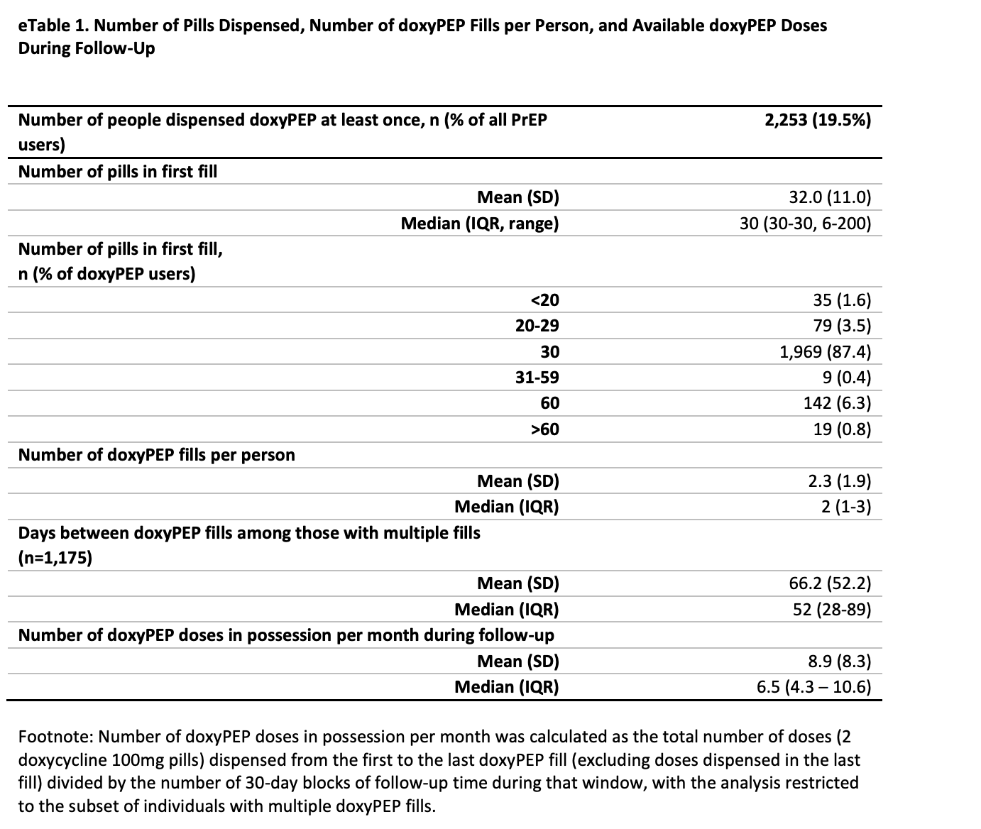

We have N = 2253 doxyPEP users. Of these, 1175 received more than one fill and 1078 received only one fill. Therefore,

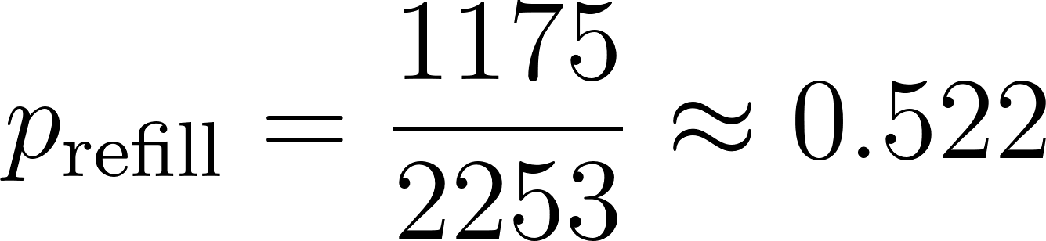
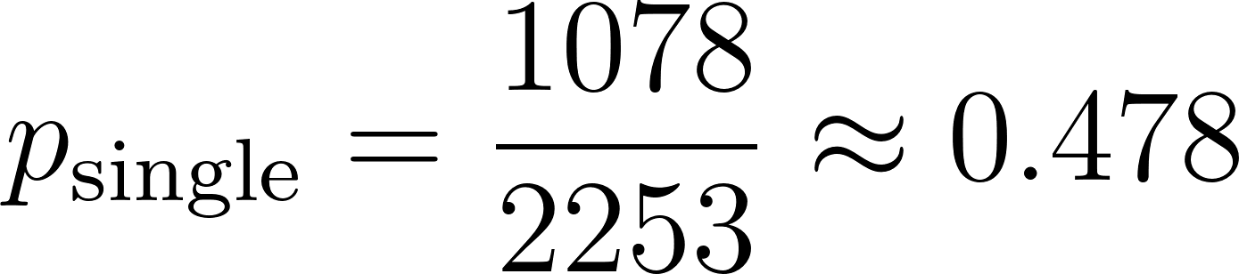

Among refillers, the median time between fills was 52 days. We use the median refill interval to approximate the continuation rate because, under an exponential assumption, the median directly determines the rate parameter and remains unbiased under censoring, providing a stable basis for approximating duration of doxyPEP use. For an exponential distribution:

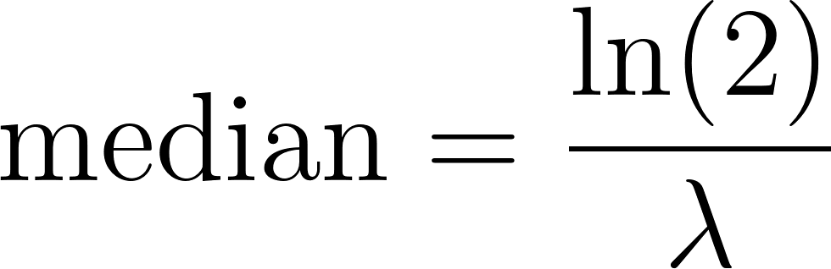

so

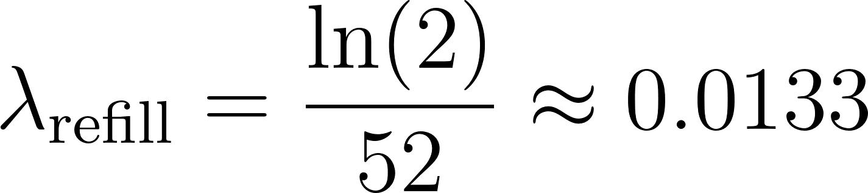

and the implied mean duration is

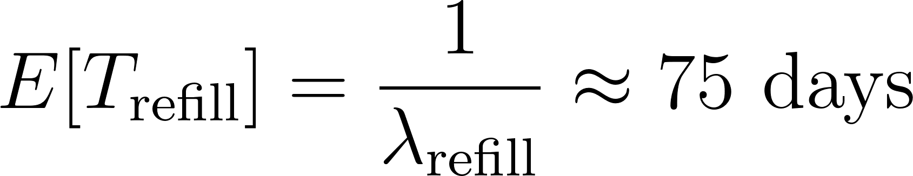

Under a high-use assumption, everyone behaves like refillers. Then

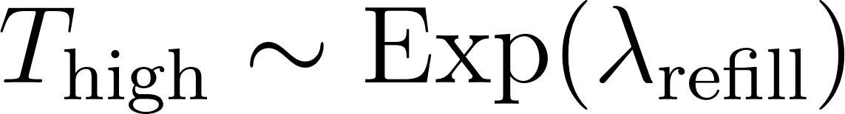

and

meaning about 37% are still using doxyPEP for 75 days.

Let I be an indicator that equals 1 for refillers and 0 for single-fill users.
I equals 1 with probability  and 0 with probability 

The overall duration T can be written as

Then the mean duration across all users is

We treat individuals without additional fills as having negligible continued doxyPEP use, so

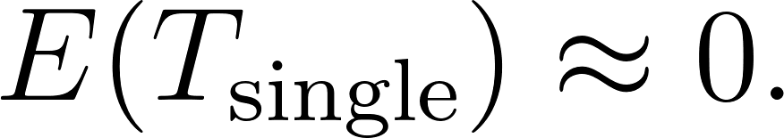

The average duration across all doxyPEP users is then the weighted average

Substituting values,

The exponential rate based on refillers is
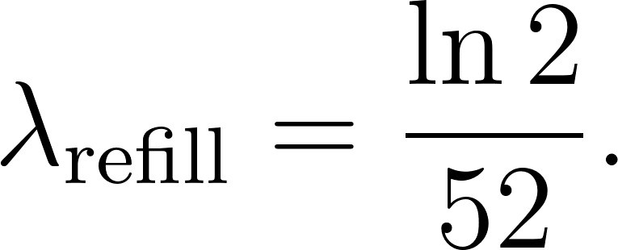

The survival probability at 75 days for refillers is

Numerically,
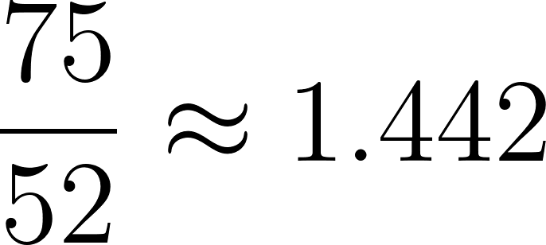
so
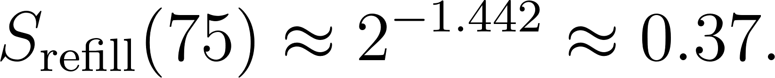

Weighting by the proportion who refill,
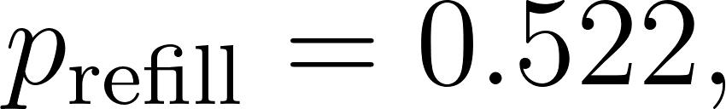

the proportion of all doxyPEP users still active at 75 days is

Meaning about 19% are still using doxyPEP at 75 days in the worst-case assumption.

